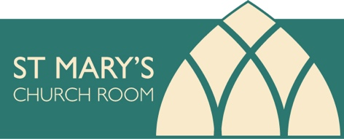
Dear All,
Despite Covid restrictions the Local Funding Group, St. Mary’s Church Room has held the following fund- raising events during 2021:
Strawberry Tea - organised by Paul and Lindsey Kennett
Walkabout
Garden Safari – 18 gardens open
Picking up the Pieces – Jigsaw Puzzle Competition
Wreath Making Workshop
Christmas at Home
As well as Rosemary Dymond’s ‘Ride and Stride’ contribution through The Friends of Kent Churches
Monday Club Sale
Donations
The total amount we have raised is £33,342. 41.

We have applied for grants from The Friends of Kent Churches and the Rochester Missional Properties Grant and received the promise of £10,000 from both trusts. Cobham Parish Council awarded Cobham Church a grant of £2,450 towards architect’s fees.

Recently, the LFG chairman, treasurer and very special IT specialist have spent every waking moment working on the Veolia grant. The application has been submitted and we are keeping fingers and toes crossed that we will be successful.

In the New Year we will continue to apply for grants. Because this is so very time consuming, I am stepping back from fund-raising to help with grant applications.

If you are considering holding a meeting, class, children’s party or other event, the present fees for hiring the Church Room are:-
Hourly Rate £ 6. 00.
Regular User Groups, 2 hours session £10. 00.
All Day - £20. 00.
Telephone Su Rowe to book 07557 990944 or 01474 814560, email surowe42@gmail.com
Or call at Sole Street House to discuss.

It would be very much appreciated in Sole Street if we could hold a Mothers’ and Toddlers’ Group, Slimming Club, Keep Fit, Book Club, IT class or, maybe, a fund-raising event for the project! We are mindful that parishioners may feel isolated as they work from home and your suggestions to help would be appreciated.

We wish you a very Happy Christmas and a Healthy and Wealthy New Year,
Keep safe.

Su Rowe,
On behalf of
the Local Funding Group
St. Mary’s Church Room

